CASE STUDIES AY 2021-2022

Case Study 2

**Name of Assignment -** Application of IoT/Ubiquitous based on cloud

**Roll No.- 33358**

**Batch- N11**

**Contact No.-** 8766925932

**Email Id-** [rapendse2002@gmail.com](mailto:rapendse2002@gmail.com)

**ID card-**

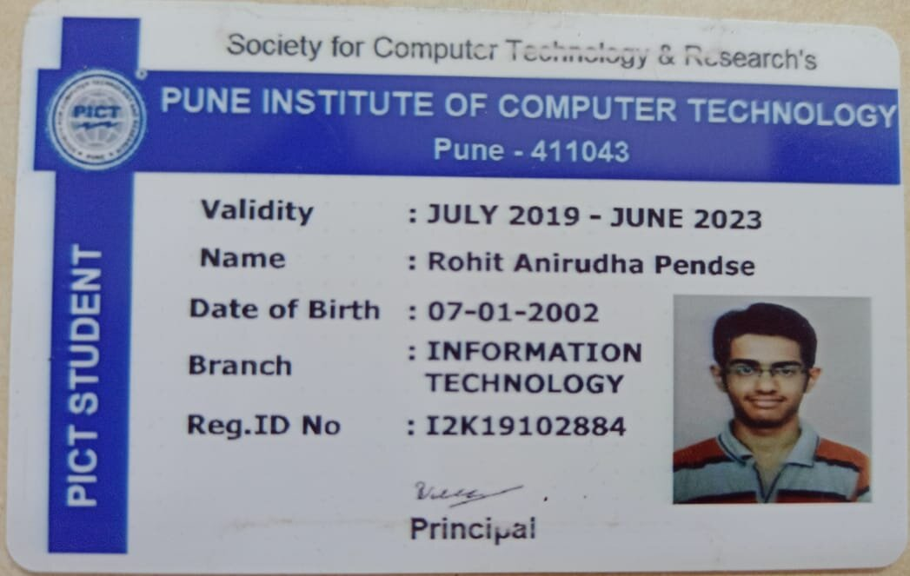

1. What is IoT?

The internet of things, or IoT, is a system of interrelated computing devices, mechanical and digital machines, objects, animals or people that are provided with unique identifiers (UIDs) and the ability to transfer data over a network without requiring human-to-human or human-to-computer interaction.

A thing in the internet of things can be a person with a heart monitor implant, a farm animal with a biochip transponder, an automobile that has built-in sensors to alert the driver when tire pressure is low or any other natural or man-made object that can be assigned an Internet Protocol (IP) address and is able to transfer data over a network. Increasingly, organizations in a variety of industries are using IoT to operate more efficiently, better understand customers to deliver enhanced customer service, improve decision-making and increase the value of the business.

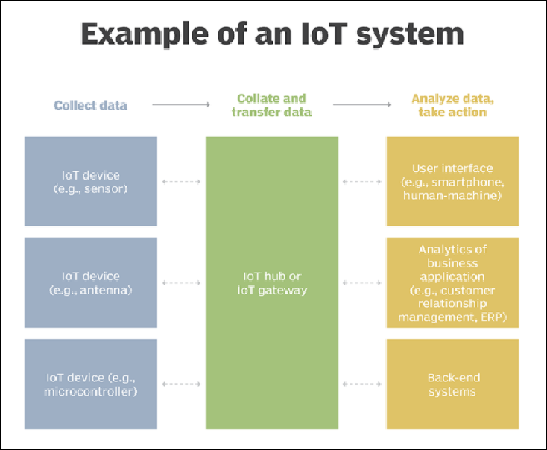

1. What is the Ubiquitous system?

Ubiquitous computing is a paradigm in which the processing of information is linked with each activity or object as encountered. It involves connecting electronic devices, including embedding microprocessors to communicate information. Devices that use ubiquitous computing have constant availability and are completely connected.

Ubiquitous computing focuses on learning by removing the complexity of computing and increases efficiency while using computing for different daily activities.

Ubiquitous computing is also known as pervasive computing, everyware and ambient intelligence. The main focus of ubiquitous computing is the creation of smart products that are connected, making communication and the exchange of data easier and less obtrusive.

1. Draw necessary diagrams for both IoT and Ubiquitous systems

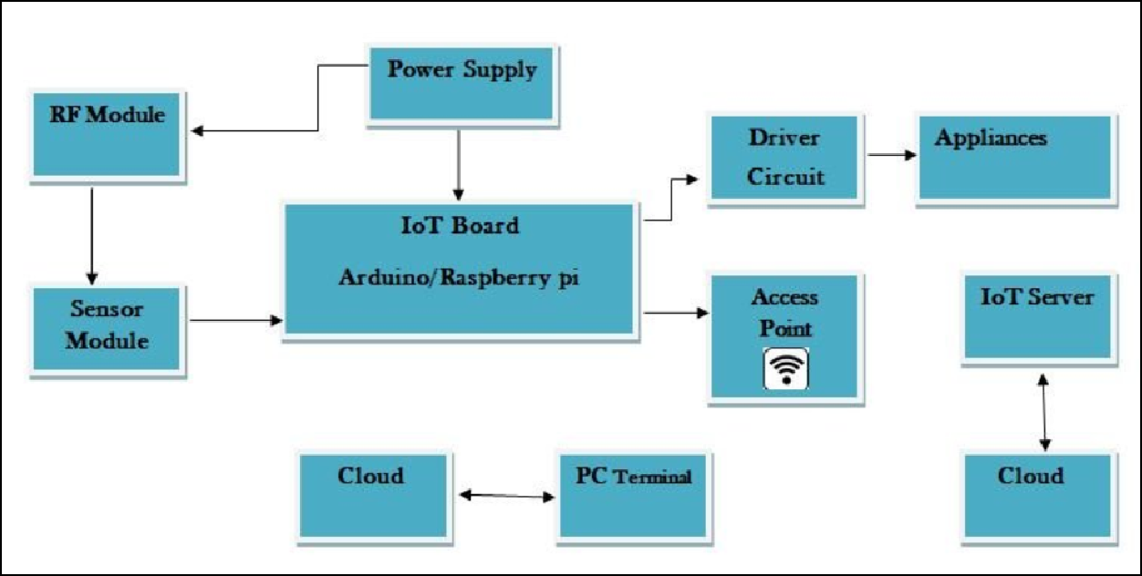

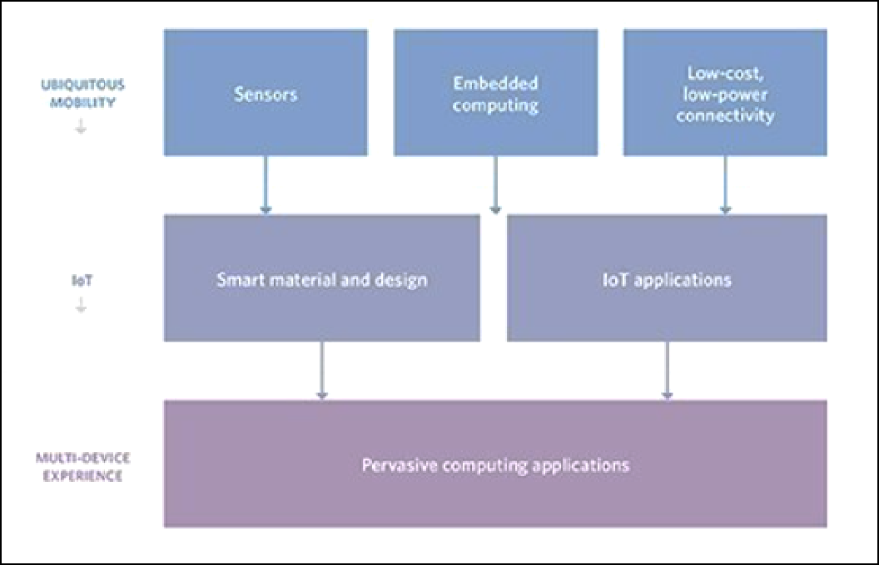

1. What applications can be built using the ubiquitous and IoT based cloud IoT:

Apart from providing smarter solutions for homes and housing communities, IoT has also been used as a tool in business environments across various industries. However, with the amount of big data that is generated by IoT, a lot of strain is put on the internet infrastructure. This has made businesses and organizations look for an option that would reduce this load.

Enter cloud computing- an on-demand delivery of computing power, database storage, applications and IT resources. It enables organizations to consume a compute resource, like a virtual machine (VM) instead of building a computing infrastructure on premise.

Cloud computing, as well as IoT, work towards increasing the efficiency of everyday tasks and both have a complementary relationship. On one hand, IoT generates lots of data while on the other hand, cloud computing paves way for this data to travel. There are many cloud providers who take advantage of this to provide a pay-as-you-use model where customers pay for the specific resources used. Also, cloud hosting as a service adds value to IoT startups by providing economies of scale to reduce their overall cost structure.

In addition to this, cloud computing also enables better collaboration for developers, which is the order of the day in the IoT space. By facilitating developers to store as well as access data remotely, the cloud allows developers to implement projects without

delay. Also, by storing data in the cloud, IoT companies can access a huge amount of Big Data.

Ubiquitous:

Ubiquitous Cloud Computing has been recently proposed as a new hybrid computing model. This paradigm has two aspects: (a) Making use of cloud services to realize context-awareness (especially for resource-limited mobile devices) and (b) Introducing a new and hybrid computing model.

The ubiquitous cloud supports various stakeholders to use appropriate ubiquitous objects in infrastructure, platform and application levels. We present an architecture consisting of four key components: the service resource registry, the adaptive resource finder, the context manager and the service concierge.

1. Success stories as example for IoT and Ubiquitous based on cloud application- put details

Amazon, Microsoft and Google have invested and built tons of computing infrastructure. These giants have rented out their computing capacity to other companies. It helps businesses to save significantly on IT infrastructure costs.

Amazon sat on top of the cloud computing mountain. It has grown into a mammoth of business that has generated more than millions in revenue in recent years. Having unique expertise in technology, customer relationships and leveraging it into the cloud. IBM has gained its position as a world class vendor.

1. **Conclusion**

We studied and learnt about the application of Iot/Ubiquitous based on cloud.